2020 LEWIS A. JACKSON AVIATION SCHOLARSHIP PARTICIPATION FORM

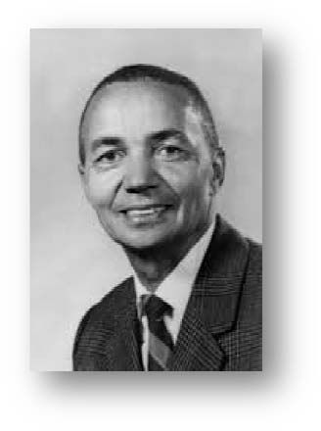

Application must be submitted by Friday, May 1.
Date ________________
Jackson Aviation Scholarship Applied for ________________________________
_______________________________________wishes to participate in the Jackson Aviation Scholarship program, which will include the following.
Program Objective The student pilot will obtain the basic knowledge, skills and aeronautical experience conducive to meet the solo aeronautical experience requirements of FAR 61.87. The student will become familiar with the training airplane and learn how to use the airplane controls to establish and maintain specific flight attitudes and ground tracks. The student will also gain proficiency in airspeed control during basic maneuvers and traffic patterns operations. They will also learn how to recognize and recover from stalls, and become familiar with the management of systems and equipment malfunctions.
Maneuvers and procedures introduced and practiced during training:
1. Preflight planning and preparation
2. Powerplant operation
3. Aircraft systems
4. Taxi and surface operations
5. Takeoff and landings – Normal and Crosswind
6. Straight and level flight, and turns in both directions
7. Climbs and climbing turns
8. Airport traffic patterns, including entry and departure procedures
9. Collision, wind shear and wake turbulence avoidance turbulence
10. Descents, with and without turns, using high or low drag configurations
11. Flights at various airspeeds from cruise to slow flights
12. Stall entry from various flight attitudes and power configurations with recovery initiated at the first indication of a stall, and recovery from a full stall
13. Emergency procedures and equipment malfunctions
14. Ground reference maneuvers
15. Approaches to a landing area with simulated engine malfunctions
16. Slips to a landing
17. Go arounds
Lesson time allocation: Each fight training lesson is designed to build knowledge, proficiency and experience based on a previous learned maneuver or task. Flight lessons will provide enough flexibility to adapt to each student’s individual needs during the training environment. The lesson will include a pre-flight discussion in which tasks to be covered during the lesson will be introduced and briefed; and a post flight briefing designed to review and cover a student performance improvement plan. As a guide, a minimum of 1.5 hours per training event is recommended. A training event is divided into 1.1 hour of flight training and 0.4 of ground discussion as a minimum.

_____________________________________________________________________________________

I certify that I am the child’s legal guardian, and I give him/her permission to participate in this program.
I also agree to hold harmless for all personal injury which might result from participation in any part of the Jackson Aviation Scholarship program all participants and sponsors of the Jackson Aviation Scholarship program which includes Greene County (Ohio), Greene County Commissioners, the Greene County Regional Airport Authority, the Greene County Airport Manager, the Greene County Community Foundation, those who contributed funding to the Scholarship program, and those involved in the selection process for Jackson Aviation Scholarships.

Legal Guardian: __________________________________________________________________
Address: ________________________________________________________________________
Telephone Number: _______________________________________________________________
Email Address: ____________________________________________________________________

